Cheesy hearts
Ingredients
175g (6 oz) butter
250g (8 oz) plain flour, plus extra for kneading
Salt and pepper
175g (6 oz) cheddar cheese
2 egg yolks
1 whole egg
Equipment
Small knife
Mixing bowl
Grater
Fork
Rolling pin
Heart-shaped biscuit cutter
Baking sheets
Small bowl
Pastry brush
ovengloves

What to do
- Set the oven to 220°C/400°F/ Gas Mark 6.
- Cut the butter into pieces and place into the mixing bowl, add the flour, salt and pepper. Rub in the butter with your fingertips until the mixture looks like fine crumbs.
- Grate the cheese, then stir three-quarters of the cheese into the mixing bowl, add the egg yolks. Mix with the fork, then shape the dough into a ball with your hands.
- Sprinkle the work surface with a little flour. Knead the ball of dough until it is smooth, then roll it out until it is 5mm (1/4 inch) thick.
- Cut out hearts or other shapes and put the biscuits spaced slightly apart on the (ungreased) baking sheets.
- Squeeze all the trimmings together, then roll out and continue kneading, rolling and cutting until all the mixture is used up.
- Beat the whole egg in the small bowl, using the pastry brush, brush the egg on to the biscuits. Sprinkle with the remaining grated cheese. Bake in the oven for 8-10 minutes until golden. Leave to cool on the baking sheets.

If you do not have any biscuit cutters, cut out triangles or squares using a small knife. ENJOY.
Cheese and courgette muffins
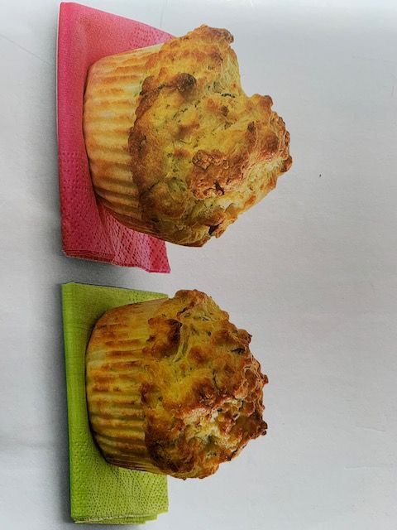
Equipment
12 – hole muffin tin
12 paper muffin cases
Large mixing bowl
Knife
Grater
Fork
Large spoon
ovengloves
Ingredients
300g (10 oz) self-raising flour
Salt and pepper
3 teaspoons of baking powder
75g (3 oz) grated parmesan cheese
1 courgette
150 ml (5 fl oz) pot natural yogurt
3 tablespoons of olive oil
3 eggs
3 tablespoons of milk

What to do.
- Set the oven to 200°C/400°F/ Gas Mark 6.
- Line the muffin tin with the paper cases.
- Put the flour, salt and pepper, baking powder and parmesan cheese into the large mixing bowl.
- Cut the stork off the courgette and then coarsely grate it. Add the courgette to the bowl. with the yogurt, oil, eggs and milk. Fork together until mixed.
- Spoon the muffin mixture into the paper cases, filling each case two thirds full.
- Bake in the centre of the oven for 18-20 minutes until golden brown and well risen.
Eat warm or cold with soup or as a snack. ENJOY.

Mini vegetable frittatas
Ingredients
250g (8 oz) baking potatoes
125g (4 oz) frozen mixed vegetables
Little oil, for brushing
75g (3 oz) cheddar cheese
6 eggs
150 ml (1/4 pint) milk
Salt and pepper

Equipment.
Vegetable peeler
Chopping board
Small knife
Small saucepan
Colander
Pastry brush
12-hole nonstick muffin or bun tin
Grater
Large jug
Ovengloves

What to do
- Set the oven to 190° C/ 375°F/Gas Mark 5.
- Peel the potatoes and cut them into small squares on the chopping board.
- Put the potatoes and the frozen vegetables into the saucepan, cover with cold water and bring it to the boil on the hob.
- Cook for 5 minutes until the potatoes are tender, drain them into a colander (be careful as it will be hot).
- Brush the holes in the muffin tin using the pastry brush with a little oil.
- Grate the cheese into a bowl, then divide the cheese and the vegetables into the holes in the muffin tray.
- Beat the eggs, milk and a little salt and pepper together in a jug. Pour equal amounts over the potatoes and vegetables.
- Put the muffin tin in the centre of the oven and cook for 10 minutes until the eggs are set and the tops are golden.

Serve warm or cold, ENJOY.

