Stay Connected

Make a Family and friend tree
This one might make you a bit sad when we can't see our loved ones at the moment, but it's a nice idea to make a family and friend tree to encourage children to talk about memories and what they want to tell family and friends when we can all get together again. Send a photo to everyone on it.
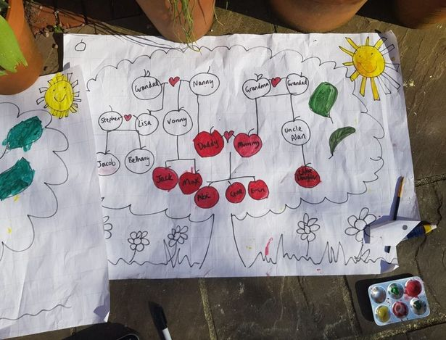
(Image: Manchester Evening News)

