Pencil control

Shadow drawing
All you need is the sun, paper and pencils. If the sun isn’t out you could always use a lamp.
Collect things from around the house or in the garden, look for interesting shapes. Carefully draw round the outline of the shadow and then colour inside the shapes you’ve made.
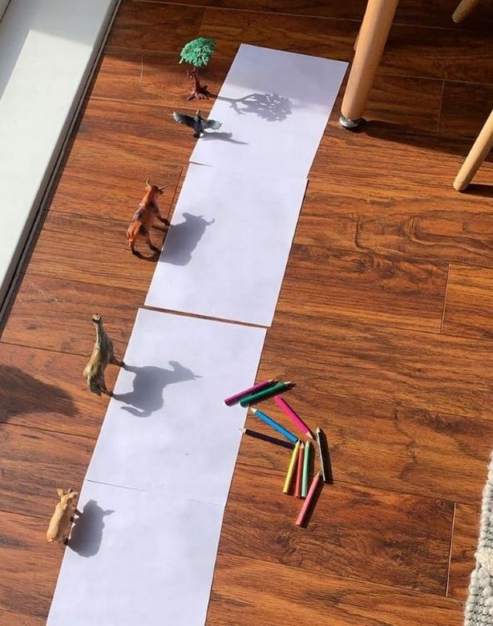
(Image: Manchester Evening News)

