Get talking

Sock puppets
Get creative and get an old sock and make your own puppet. Whether you have some stick-on googly eyes, buttons or just some scraps of paper, you can make your own character that your child will love. Give your puppet a name and make up your own stories.
You could use a cardboard box to make a puppet theatre. Send us your photos.
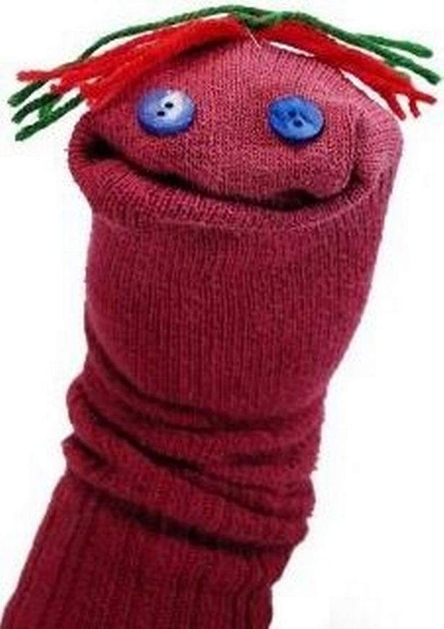
(Image: Manchester Evening News)

