Mess free play
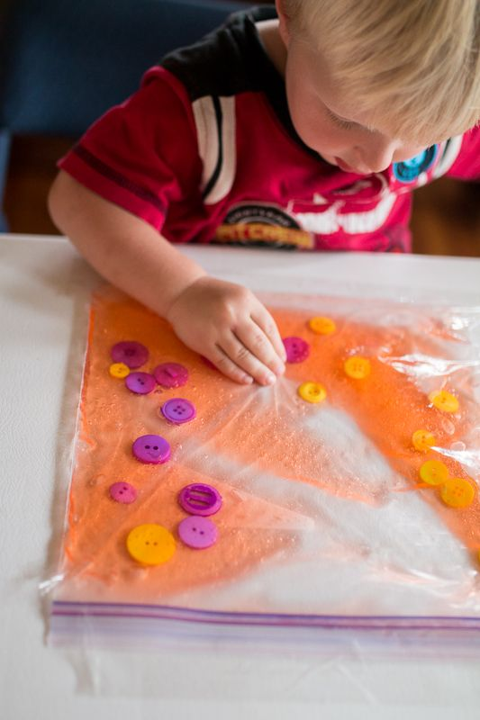
Sensory exploration
- A food bag that seals such as Ziploc (sellotape can be placed around the edges for reinforcement).
- Choose either hair gel, shaving foam, slime or paint.
- You can use a wide range of items to place inside such as: buttons, sequins, foam shapes, pom poms and natural objects like leaves and seeds.
Talk about what you can see.
How it feels.
What colours there are and what happens as the colours mix.
Can you arrange the buttons into a shape or pattern – talk about what and how they want to achieve it.

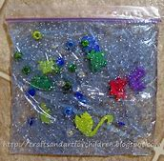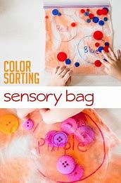

Once exploration has finished why not extend the activity by using cotton buds or even the child’s own finger to mark make (remember to be gentle you don’t want to make a hole in the bag).

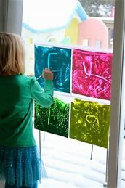

-------------------------------------------------------------------------------------------------------------------------------------

Exploring feelings and roleplay.

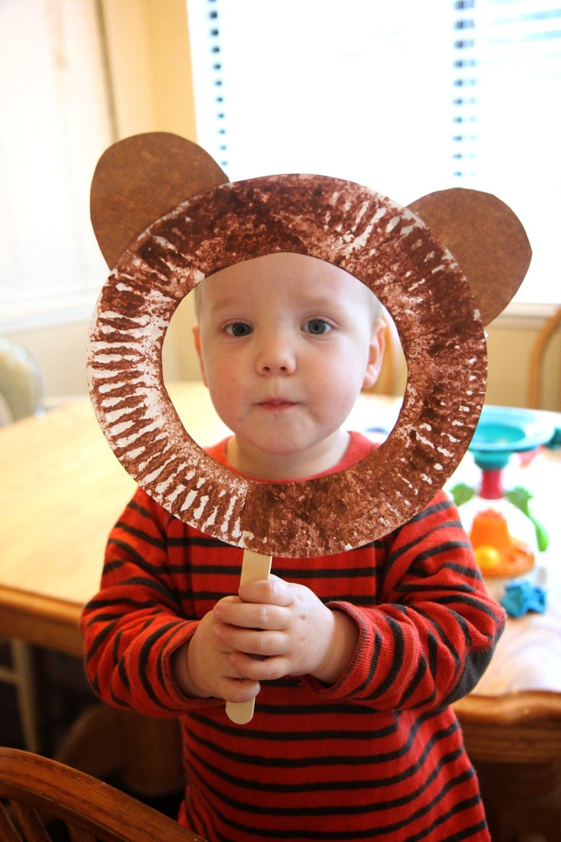
What you need:
Paper plate
Lolly stick or an actual stick
Scissors and tape.
Mirror
Cut centre out of paper plate, and attach stick.
Ask your child to make different faces, using the mirror to watch themselves. Can you show me a happy face.
Ask what makes them:
Happy/sad/angry/scared/sleepy/excited. Can you think of any others?
You could always role model if they are reluctant to join in at first.

