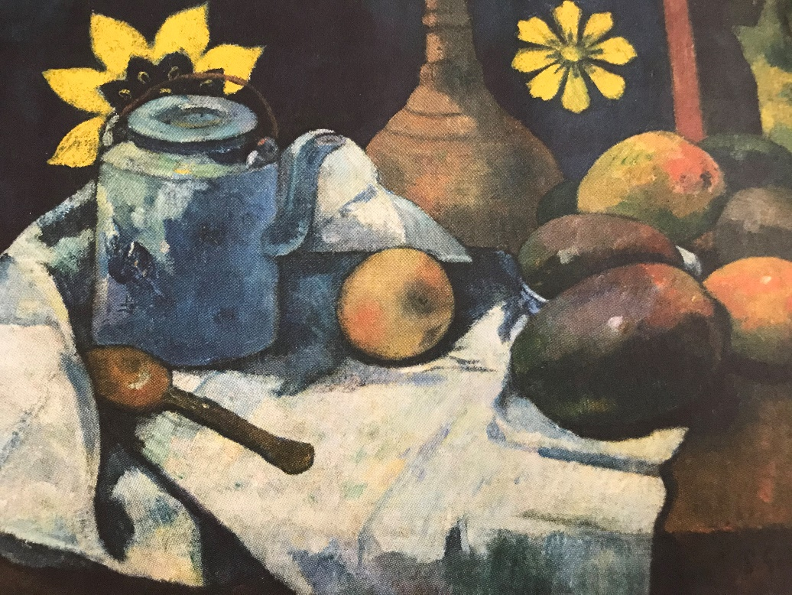
Hello everyone, I hope you have been practising your drawing skills.
This painting is a STILL LIFE painting by an artist called Paul Gaugin. He was born a very long time ago in 1948.
He painted colourful, calm pictures of collections of things that don’t move. This is why it’s called a still life painting.
Why don’t you make a still life collection. You can arrange them in a bowl, on a table – wherever you want and however you think looks great.
You can take a photo of your still life arrangement and do an amazing observational drawing.
It’s as simple as this, see?
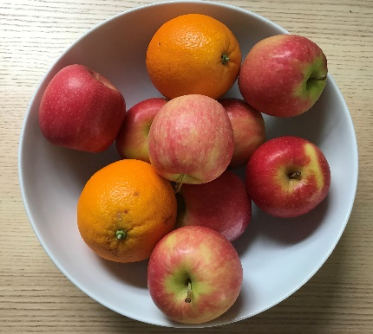
Look at the different, shapes, patterns and colours.
Get all your family involved – be artists together!
Don’t forget to send them to us – have fun!
Lots of love from Carolyn xxx

