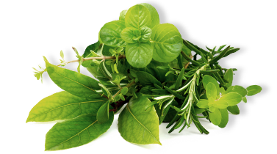

**Drawing**

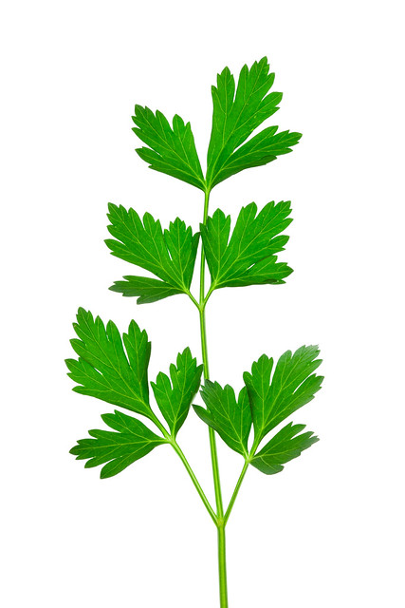

Parsley leaves have a very interesting shape. Can you draw them?

**Using our senses**

**Herbs**

**Let’s learn outside.**

Take a walk and use the 5 senses explorer hunt to discover the world around you.

Can you find any herbs?

**Did you know:**

Herbs are plants that are grown for food or because they have some use in staying healthy, or for spiritual reasons.

Have you got any herbs in your fridge or kitchen cupboard?

Look at the packaging of your food to see if there are herbs in the ingredients.

What do they taste like?

**Exploring herbs and smelly things.**

Provide your child with a sensory tray to explore and investigate using their senses.

This could include:

Rose petals

Bunches of fresh herbs to cut with scissors

Dried herbs

Lavender

Tea leaves (open a tea bag)

Bottles and water to make perfumes.

A pestle and mortar to mix together.

Some playdough to roll in the herbs.

**Why don’t you ……**

Add some dried herbs to water and freeze in ice cube trays overnight.

Explore the ice cubes the next day or place in a bowl of water for a wonderful, smelly, sensory experience.

Plant a herb garden in a pot and make your own labels for the herbs so you can smell them and remember their names.

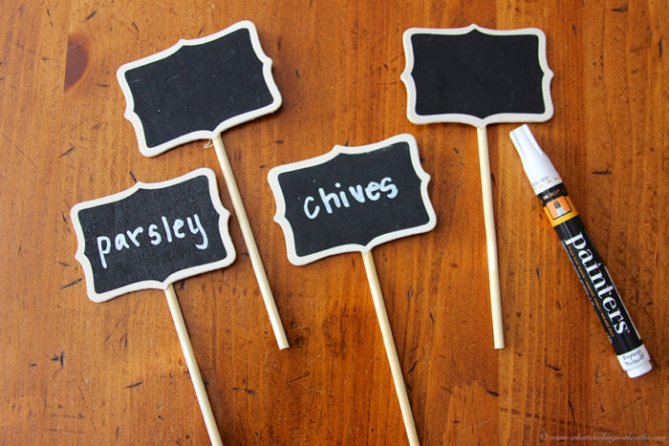

**Recipe for Herby Dips**

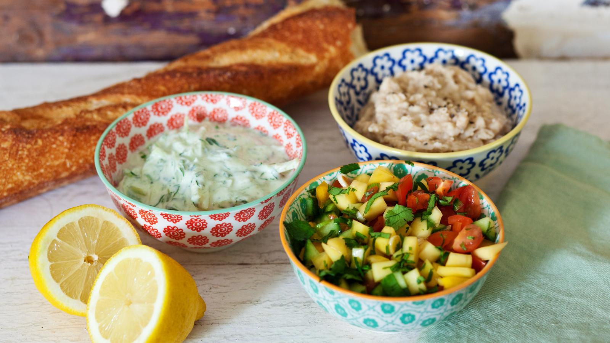

**For the cucumber yoghurt dip**

* ½ [cucumber](https://www.bbc.co.uk/food/cucumber)
* 150ml/5fl oz plain [yoghurt](https://www.bbc.co.uk/food/yoghurt) (or a dairy-free alternative)
* 1 tsp [lemon juice](https://www.bbc.co.uk/food/lemon_juice)
* small bunch fresh herbs such as mint, [coriander](https://www.bbc.co.uk/food/coriander) or parsley

**Kid’s job:** Grate the cucumber with a rotary grater or box grater (a grown up should supervise this). Add to a bowl with the yoghurt, lemon juice, olive oil. Add any herbs if you like, chopped with scissors. Stir well and then taste- add more lemon or seasoning as needed.

**For the fruity salsa**

* 10 [cherry tomatoes](https://www.bbc.co.uk/food/cherry_tomatoes) (or 3 larger tomatoes)
* 1-2 [spring onions](https://www.bbc.co.uk/food/spring_onion), chopped finely with scissors
* ½ [cucumber](https://www.bbc.co.uk/food/cucumber), chopped
* ½ [mango](https://www.bbc.co.uk/food/mango), peel removed by an adult, chopped
* handful of [sweetcorn](https://www.bbc.co.uk/food/sweetcorn) (fresh, tinned or frozen and defrosted)
* small bunch herbs, such as mint, [coriander](https://www.bbc.co.uk/food/coriander) or parsley, chopped
* 1 tsp [olive oil](https://www.bbc.co.uk/food/olive_oil)
* squeeze of [lemon juice](https://www.bbc.co.uk/food/lemon_juice)

**Kid’s job:** Carefully chop the cherry tomatoes or big tomatoes into small pieces (a grown up should supervise this) stir the chopped tomatoes together with the chopped spring onions (use scissors), cucumber, mango and sweetcorn. Mix in any chopped herbs you want to add, with a teaspoon of olive oil and have a taste. You may want to add a squeeze of lemon or a pinch of sugar.

**Serve with vegetable sticks, baked potatoes, potato skins, pitta breads or flatbreads. These will keep in the fridge for two days.**

**Please supervise your children and teach them how to use the kitchen tools safely and correctly.**

**Remember to always wash your hands before preparing and eating food.**

**ENJOY!**

**Developing early maths skills.**

Sorting

Make collections of coloured objects. Sort them out, for example all the objects that are pink and all the objects that are NOT pink.

Talk about which collection has the most and which has the least.

Count the objects.

Go on a colour walk and tally the colours you see, you get a bonus of 7 points if you see a rainbow!

RECOGNISING NUMERALS.

GO ON A NUMBER HUNT

Numbers are everywhere – it is fun to hunt for them on a walk!

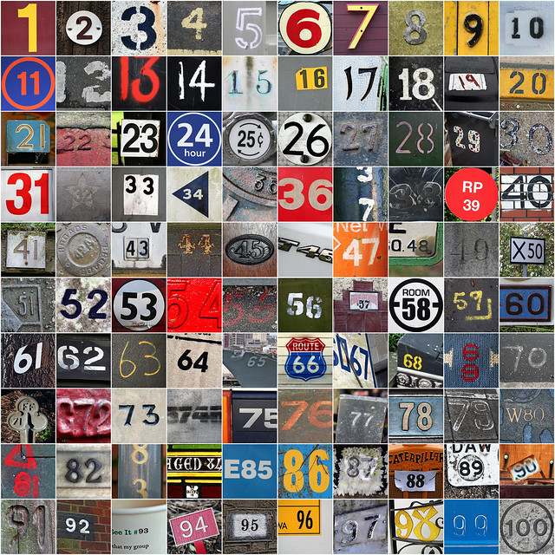

Which numbers did you find?

**Developing early phonic skills.**

It is important that children are able to hear the different sounds in words and can hear when words rhyme. Rhyming words sound the same at the end but with different initial sounds.

E.G. cat – bat – rat – sat – mat - fat etc etc

Have a go at saying rhyming strings of words. You can even make up silly words as long as they rhyme.

Such as: Butterfly – sutterfly – cutterfly.

Make up funny words to rhyme with your name.

Make collections of objects that rhyme.

Can you find stories that rhyme? Try these:

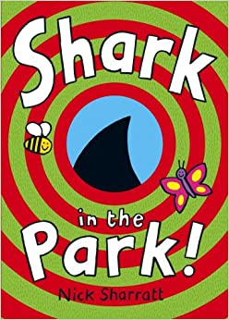 [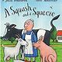](https://www.teachingchildrenphilosophy.org/BookModule/ASquashAndASqueeze) 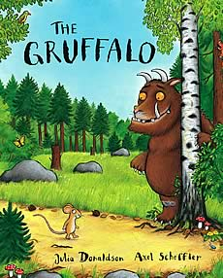

Listen to the song version of A Squash and a Squeeze at ………………

**Getting Ready for School**

**Have fun learning together with your child and helping them to develop the skills they need to become successful learners at school.**