**We books.**

The Day the Crayons Quit by Drew Daywalt

Brown Bear, Brown Bear by Eric Carle

**Exploring and making bubbles.**

Pour water into a bowl, sink or bath, add washing up liquid and use different utensils to mix together. Use a whisk, spoon, potato masher or your fingers.

Look what happens.

Look at the colours you can see in a bubble.

Can you scoop the bubbles up and blow them?

What have you discovered?

**Let’s learn outside.**

What’s the weather like today?

Look around you and look at the sky.

Can you feel the rain, the wind or the sun?

   

If it’s raining and sunny search for a rainbow.

Can you find some dandelion seeds and blow them away?

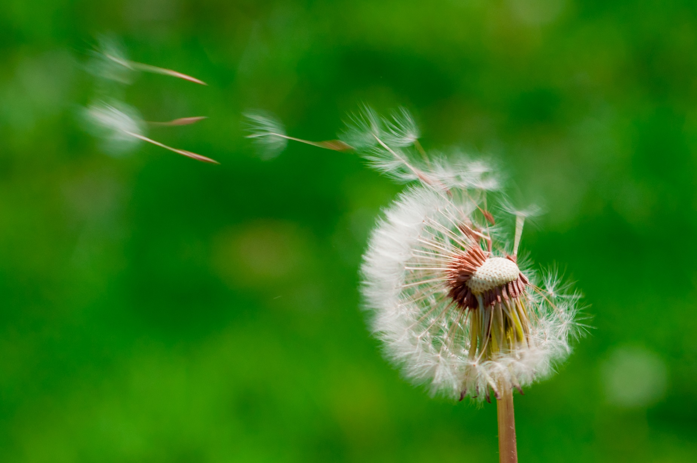

**Drawing**

Using a pencil or crayons draw lines to make the shape of a rainbow.

Start at the bottom on the left side and make the arc, coming all the way down on the other side too.



If you are colouring in stay carefully within the lines.

Can you think of any letters that have this shape?

m n e h r

**Recipe**

**Make a rainbow salad or fruit salad.**

**Choose different coloured foods and arrange them in a rainbow.**

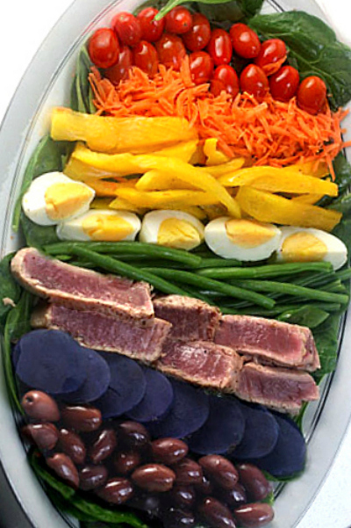

**COLOURFUL HEALTHY SNACKS.**

RAINBOW COLOURS



**Being Creative**

Wassily Kandinsky is a famous artist from Russia. He used lots of bright colours in his artwork. Look up his paintings, can you use lots of colours too in your pictures?

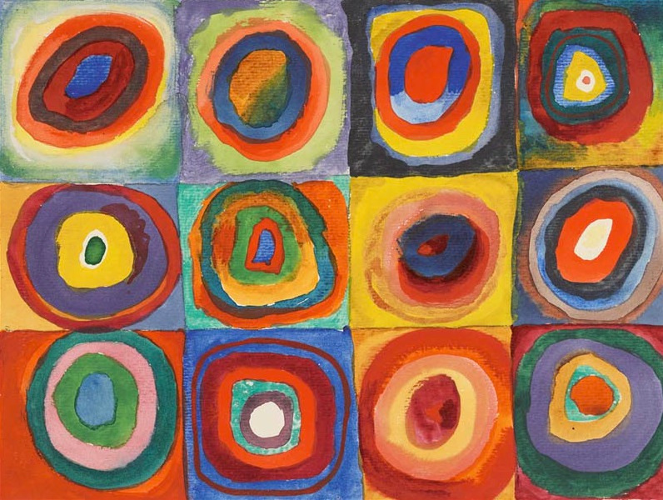

Find different coloured paper, food wrappings, tear from magazines and make a rainbow collage. Make sure you have

red orange yellow green blue indigo violet

**You can sing a rainbow**



**Red and yellow and pink and green, Orange and purple and blue.**

**I can sing a rainbow, sing a rainbow, you can sing one too!**

**Listen with your eyes, listen with your eyes,**

**and sing everything you see.**

**You can sing a rainbow, sing a rainbow, sing a- long with me.**

**Red and yellow and pink and green, orange and purple and blue. You can sing a rainbow, sing a rainbow, now you've sung one too!**

**Singing together is good for your well being – why not sing it over the fence to cheer up a neighbour – pass on the song.**

**The music is online for you!**

**Developing early maths skills.**

Sorting

Make collections of coloured objects. Sort them out, for example all the objects that are pink and all the objects that are NOT pink.

Talk about which collection has the most and which has the least.

Count the objects.

Go on a colour walk and tally the colours you see, you get a bonus of 7 points if you see a rainbow!

**Getting Ready for School**

**Have fun learning together with your child and helping them to develop the skills they need to become successful learners at school.**

**Developing early phonic skills.**

It is important that children are able to hear the different sounds in words to be able to segment and blend the sounds.

Have a go at clapping words and names.

Such as:

Ca - ro - lyn (3 claps)

Ca – ter – pill – ar (4 claps)

This helps children to learn how to separate the sounds in words and understand how they are blended together to say and read.

|  |
| --- |
| 1 |
| 2 |
| 3 |
| 4 |
| 5 |
| 6 |
| 7 |
| 8 |
| 9 |
| 10 |

** CUT OUT FOR LABELS**