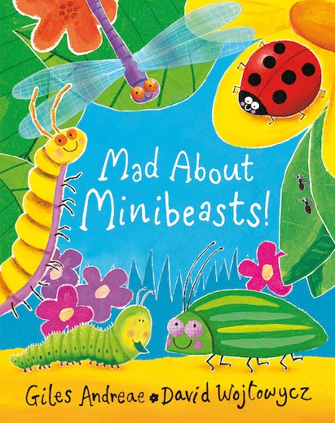 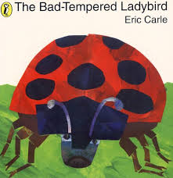

**Listen to Music and Dance.**

Listen to the music called:

The Flight of the Bumble Bee.

You can find some animated versions on youtube.

Eg The flight of the bumble for kids.

Can you flap your wings and buzz around like a bee?

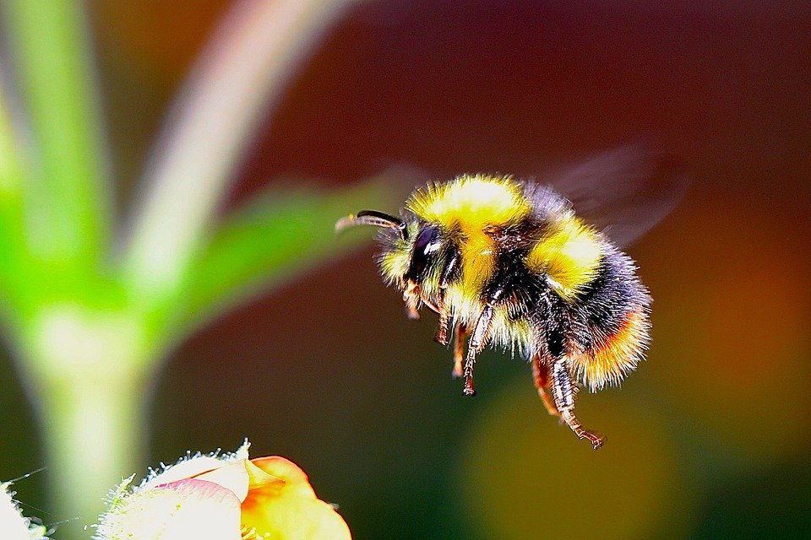

Why don’t you make some honey sandwiches and go on a picnic?

Help your child to use knives safely to spread the butter and honey and cut the sandwiches in half.

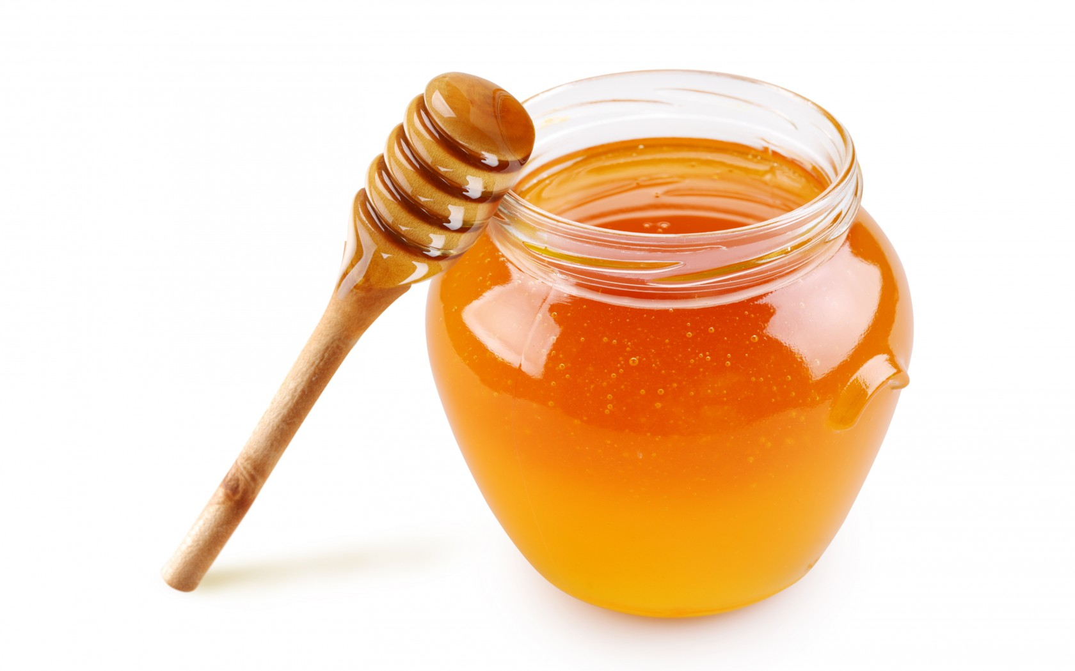

**We books.**

The Bad Tempered Ladybird by Eric Carle.

The Very Busy Spider by Eric Carle.

Mad About Mini Beasts by Giles Andreae

Superworm by Julia Donaldson

**Searching for mini beasts**

Use the chart to search for creepy crawlies. Tick them off when you have found them.

Talk about where you found them and what they were doing.

Make sure you leave them safe and well in their home!

**Let’s learn outside.**

When you go on your walk listen out for the buzz of a bee.

Can you make the sound? How long can you make it last before getting out of breath?

Take in a deep breath and … Buzzzzzzzzz

What colour flowers do you see bees on? They are usually attracted to yellow or orange flowers.

Talk to your child about how important bees are. Not only do they make delicious honey but they also help to transfer pollen from plant to plant to help new plants grow.

We can help the bees by planting flowers friendly plants in our garden and pots. Wildflowers, lavender and bluebells are all rich in nectar – bees love them.

Bees and Bugs 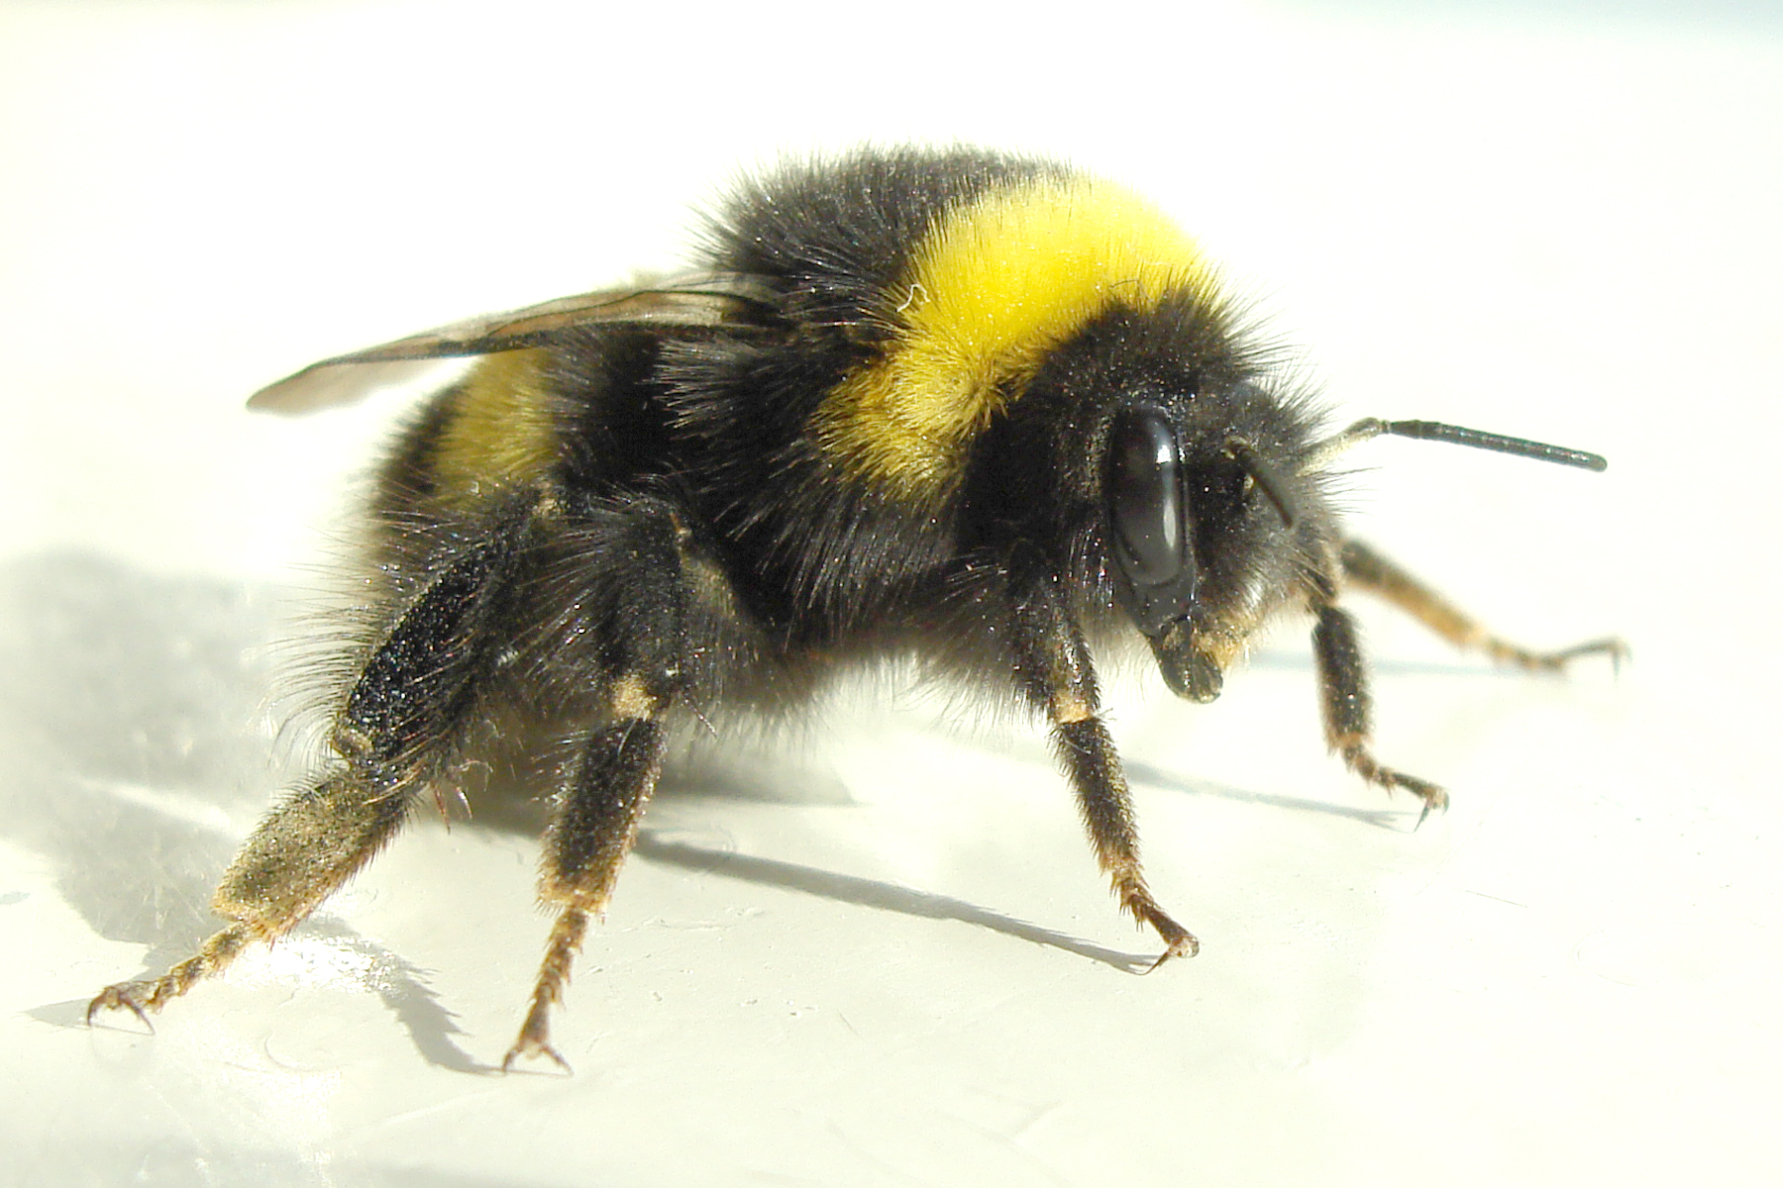

Do you recognise this bee?

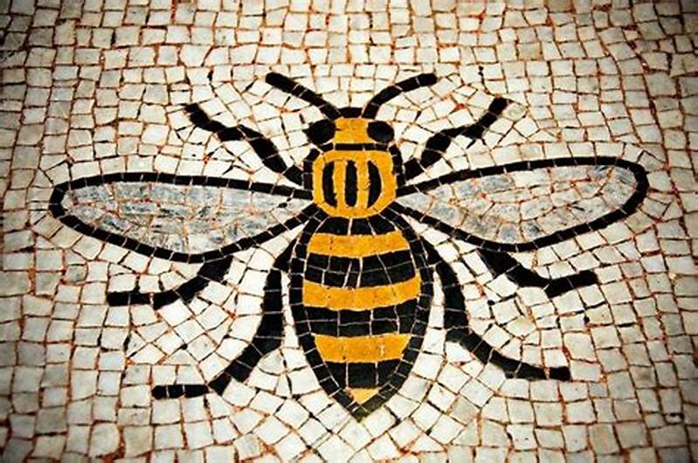

This is a mosaic of the **Manchester worker bee. It is in the town hall and is one of the best-known symbols of Manchester. It has** been an emblem for the city for over 150 years. The bee denotes [Mancunians](https://www.bing.com/search?q=Manchester&filters=sid%3a35dddbb1-7bb3-4072-bfd5-f9e6570713b0&form=ENTLNK)’ hard work ethic and the city being a hive of activity. It has also come to represent the sense of unity in this great city.

Can you draw the Manchester Bee?

You could cut out squares of black, white and yellow to make a bee mosaic.

Look at the patterns on minibeasts. Look closely. Can you draw them?

Bees are stripey. 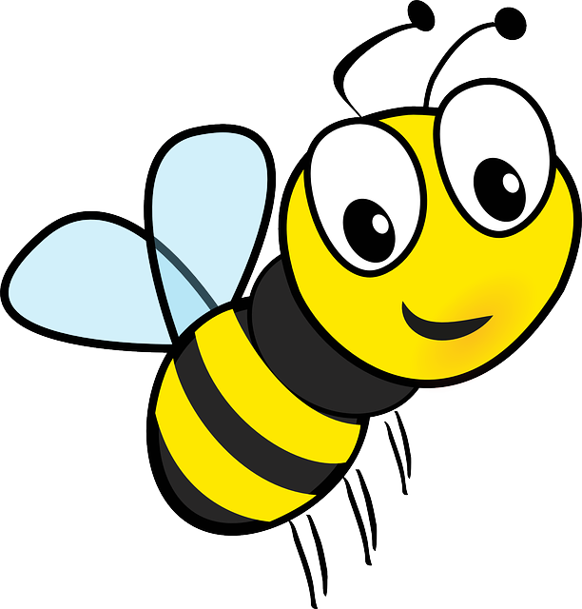 Lady birds have spots. 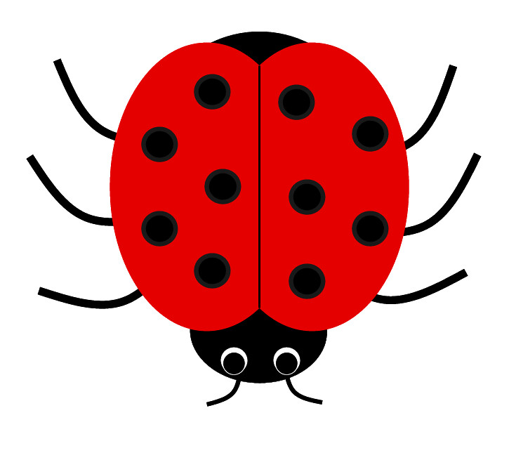

Snails have a spiral pattern on their shells.

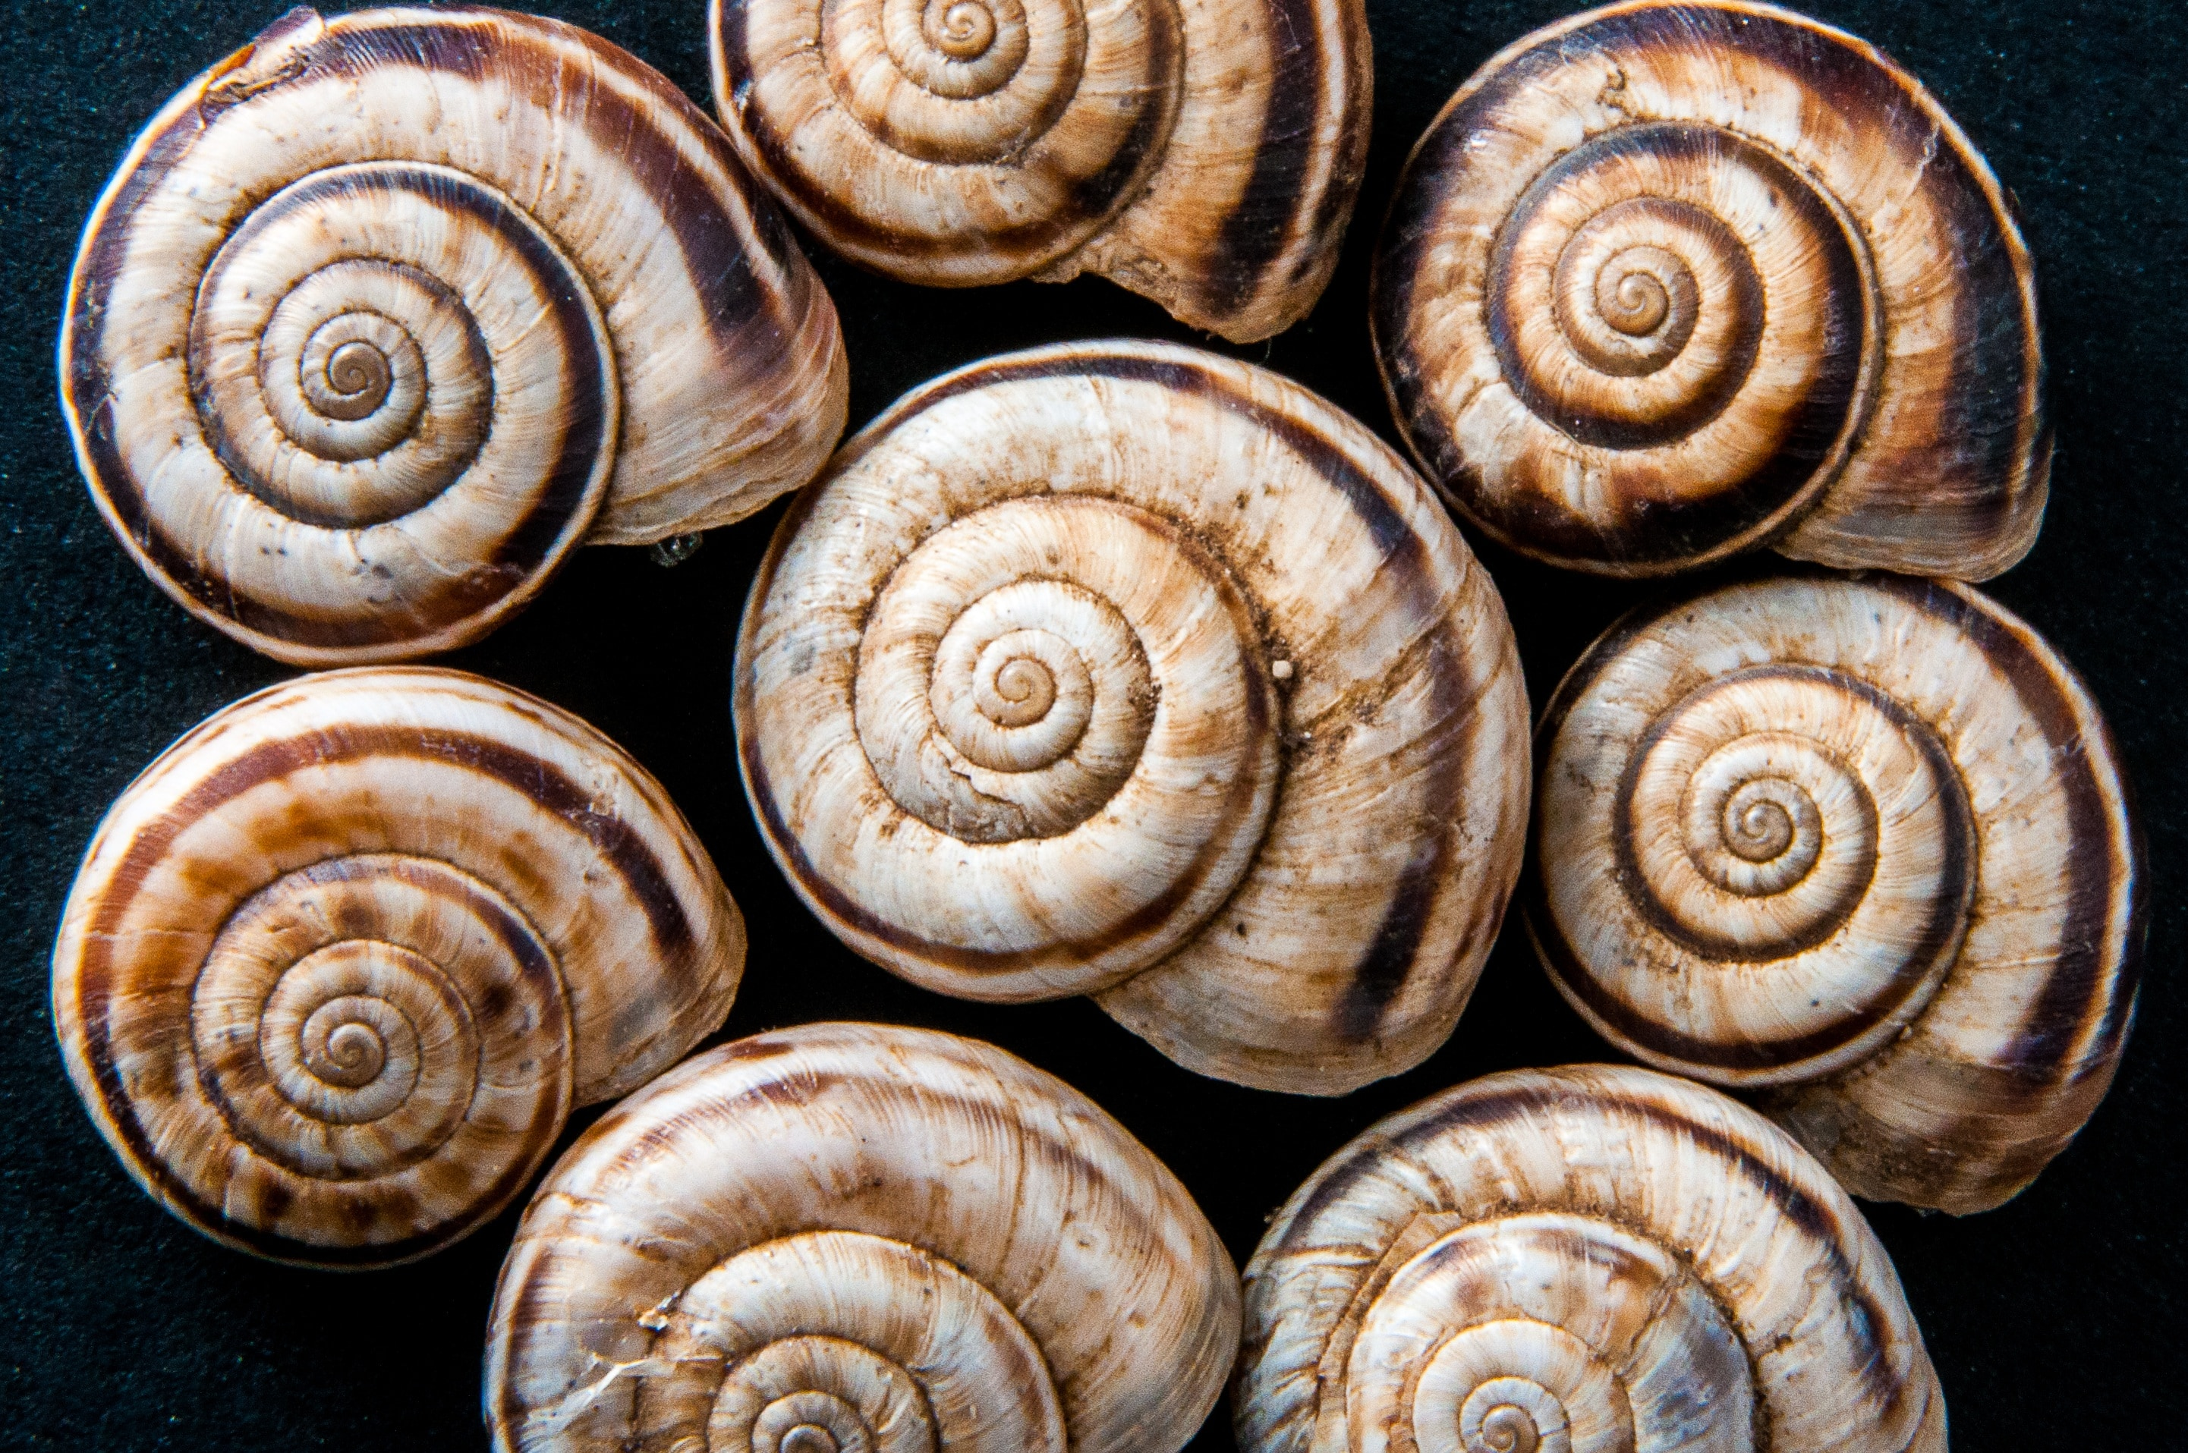

When you draw a spiral start in the middle and and go round and round to the outside.

Try starting on the outside and go smaller and smaller into the middle – which is easiest?

**Developing early phonic skills.**

It is important that children are able to tune into different sounds to begin to hear and discriminate between speech sounds.

Identify the beginning sounds in words.

What’s the beginning sound in your name, can you find other things that begin with that sound?

EG C for Carolyn and …. Cat and …. Car etc etc.

What does the letter look like that makes that sound? Can you write it?

**Play I-SPY**

**Developing early maths skills.**

**Let’s measure things.**

What can you see growing outside?

Get a tape measure or a stick or a piece of wool and measure how tall the flowers are.

Measure how tall you are – you are all growing up so fast. Who is the tallest in your family?

Why don’t you do some baking and weigh out the ingredients, or use measuring jugs?

**Exploring wonderful water**

Use a variety of containers and jugs in a bowl of water to give your child a real sense of how much each holds. Explore how full and empty the containers are and discuss more, less, full, fuller and empty as you play. Your child will experience capacity first hand.

**Spaghetti Fun**

To colour spaghetti wash it once cooked and place in a bowl of coloured water for a few hours. This creates a bright, exciting and tactile opportunity for play and exploration, as well as a way to discuss the concept of length. Teach your child how to use scissors correctly and safely so they can create *short, shorter* *and even shorter* lengths of spaghetti! A great opportunity to compare two strands by their length: “Which is longest?” “Which is shortest?” “Which are the same?”

**Getting Ready for School**

Have fun learning together with your child and helping them to develop the skills they need to become successful learners at school.