**We books.**

Jasper’s Beanstalk.

Planting a Rainbow.

The Tiny Seed.

**Let’s learn outside.**

When you go on your walk see how many different colours of flowers you can see.

Count how many flowers you find.

Do you know the names of the flowers?

Did you see any insects on the flowers?

Take a photograph of the flowers to draw later.

Can you find a rose to smell?

Collect daisies and buttercups to use when you are home.

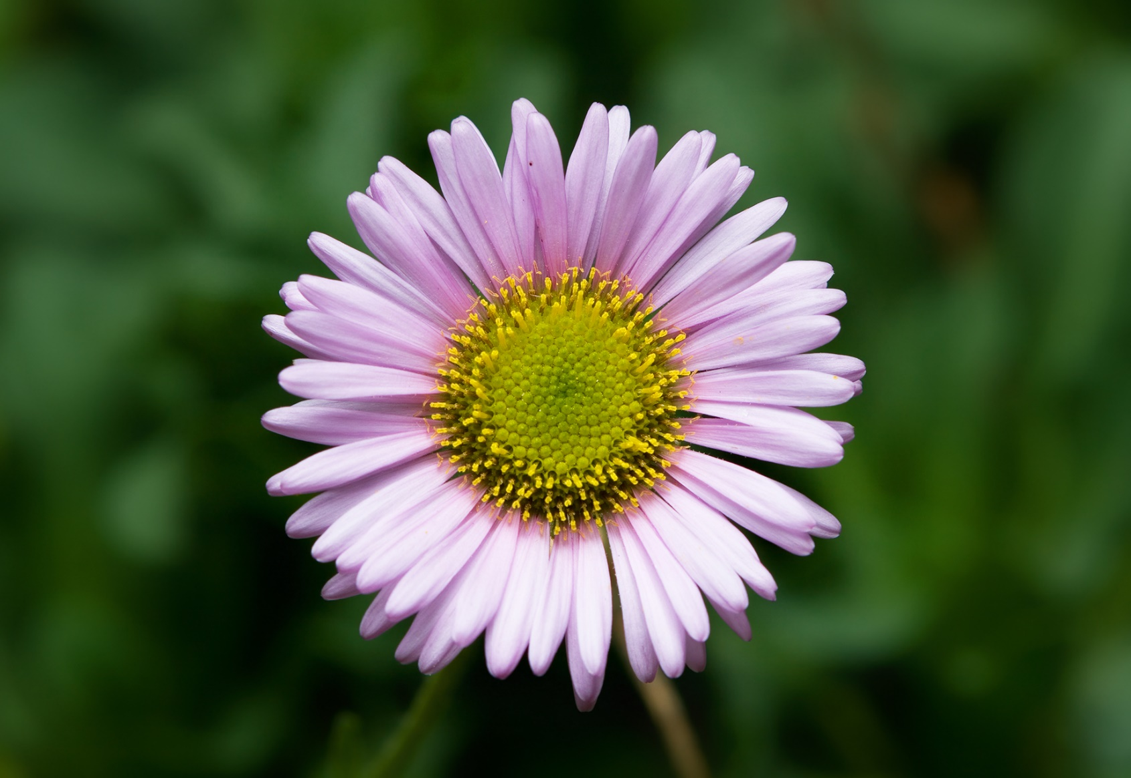

**Froyo Bites Recipe**

(From superhealthykids.com)

You will need:

Plain Greek yoghurt and 2 types of berries, eg blueberries for purple bites and strawberries for pink.

Wash the berries.

Blend 1 cup of yoghurt and 1 cup of the berries together.

Scoop the mixture into ice cube trays and freeze for a couple of hours.

Now they are ready to eat!!!

**DELICIOUS and HEALTHY**

FLOWERS 

**Drawing**

Just using a pencil or a pen look closely at flowers you have collected and draw them. Make sure that you draw the shape of the petals and include lots of details.



**Exploring and making ice.**

Pour water into containers and add your flowers, daisies and buttercups that you have collected. You could use empty, washed egg shells. Place the containers into the freezer and leave for a few hours until they are frozen. Put the ice blocks into a sink or bowl of water and watch what happens.

What have you discovered?

**Use your Imagination.**

Why don’t you make a fairy garden?

You can do this in your garden, in a tray, a flower pot or even in a jar.

Collect the resources you may need and make them out of boxes, card and cartons.

Make up a story.

Ideas for resources:

Glass beads

Mirrors for water

Pebbles and Stones

Small plants that children can grow

Petals

Signs

Fairy door ...

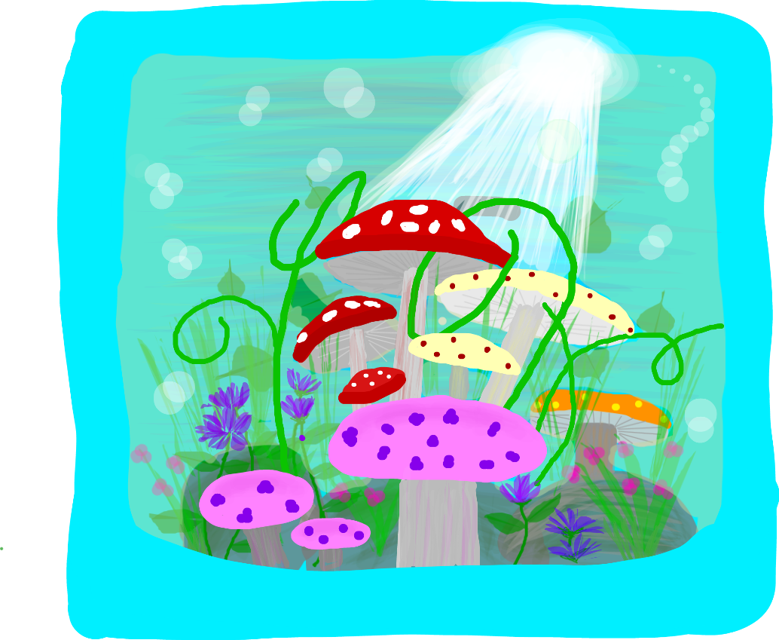

**Being Creative**

Look up these artists, can you draw or paint some beautiful flower pictures too.

**Georgia O Keefe Andy Warhol**

 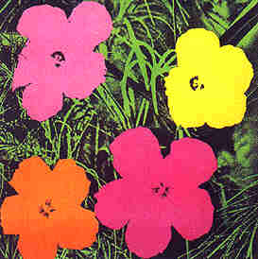

**Use the flowers and petals you collected to make flower collages or fairy wings.**

**Developing early maths skills.**

This week concentrate on counting 1 to 1 accurately and recognising the corresponding numbers. Draw a simple grid or print one out for children to place daisies or buttercups on, 1 in each square.

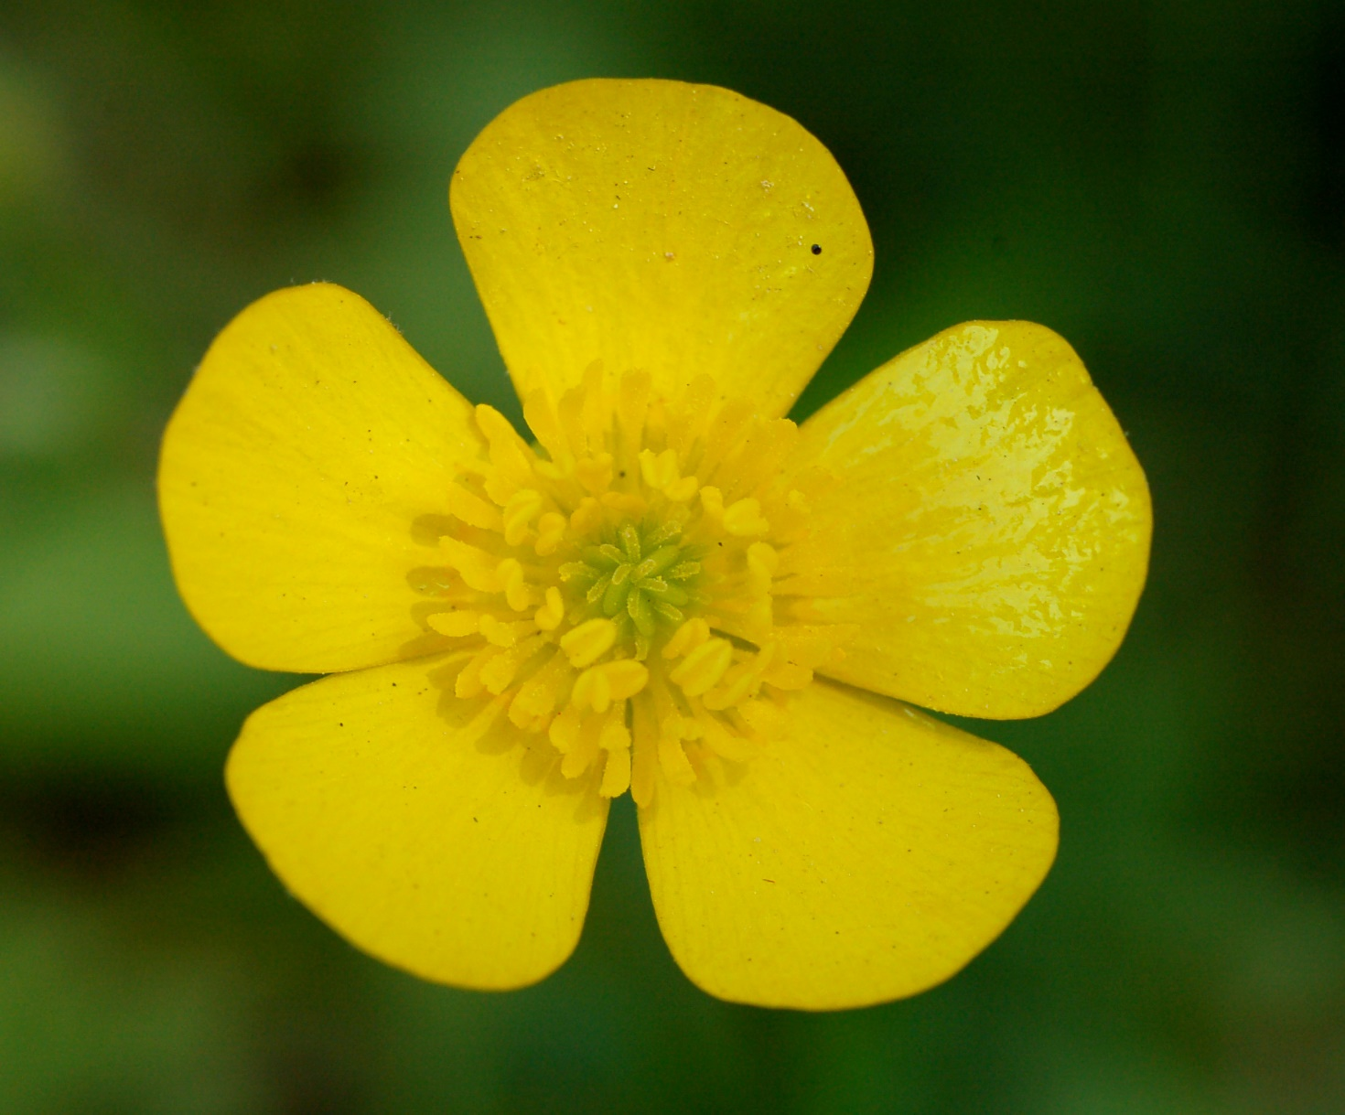    

1 2 3 4 5

**Getting Ready for School**

**Have fun learning together with your child and helping them to develop the skills they need to become successful learners at school.**

**Developing early phonic skills.**

It is important that children are able to tune into different sounds to begin to hear and discriminate between speech sounds.

Here are a couple of activities to do this week to encourage your child to listen and respond to sounds.

**MUSICAL STICKS**

On a walk collect a couple of sticks and bank, tap and scrape different things, noticing the sounds you can make. For example, drag the stick along a railing or scrape it up the trunk of a tree.

**SHAKE and STOP**

Make shakers out of yoghurt pots and put different things inside, eg, lentils, feathers or beads. Listen to the sounds you make and see if you can guess what is inside.

|  |
| --- |
| 1 |
| 2 |
| 3 |
| 4 |
| 5 |
| 6 |
| 7 |
| 8 |
| 9 |
| 10 |