**Using our senses**

**Smelly things.**

U3s

**Let’s learn outside.**

Take a walk and explore what you can smell.

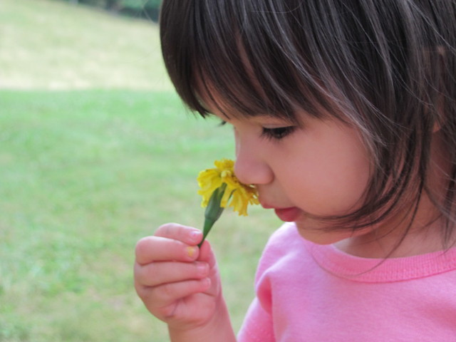

**Smelly socks**

Use some old socks and fill them with smelly things, such as curry powder, dried herbs lavender. Tie them tight with string at the top and hang them on a washing line.

Can your child identify the smells and match the smells. Which do they like best?

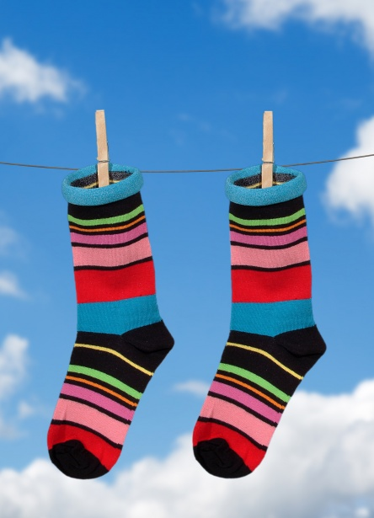

**Exploring herbs and smelly things.**

Provide your child with a sensory tray to explore and investigate using their senses.

This could include:

Rose petals

Bunches of fresh herbs to pull, tear and squeeze.

Dried herbs

Lavender

Tea leaves (open a tea bag)

Bottles and water to make perfumes.

Some playdough to roll in the herbs.

**Did you know:**

Herbs are plants that are grown for food or because they have some use in staying healthy, or for spiritual reasons.

Have you got any herbs in your fridge or kitchen cupboard?

Look at the packaging of your food to see if there are herbs in the ingredients.

What do they smell and taste like?

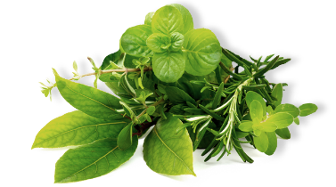

**Why don’t you ……**

Add some dried herbs to water and freeze in ice cube trays overnight.

Explore the ice cubes the next day or place in a bowl of water for a wonderful, smelly, sensory experience.

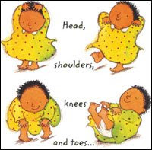

**Head, shoulders, knees and toes, knees and toes.**

**Head, shoulders, knees and toes, knees and toes.**

**Eyes and ears and mouth and nose.**

**Head, shoulders, knees and toes, knees and toes.**

**Developing early maths skills.**

Sorting

Make collections of coloured objects. Sort them out, for example all the objects that are pink and all the objects that are NOT pink.

Talk about which collection has the most and which has the least.

Count the objects.

Go on a colour walk and tally the colours you see, you get a bonus of 7 points if you see a rainbow!