**Using our imagination**

**Small world animals.**

U3s

We love books 

Dear Zoo by Rod Campbell

Rosie’s Walk by Pat Hutchins

Dinosaur Roar by Henrietta Strickland

Farmer Duck by Martin Waddle & Helen Oxenbury

**Imaginative play**

Explore and play with small world animals.

What are the animals called?

What sounds do they make?

What are the baby animals called?

Make a vets area at home.

Use your soft toys and teddies as patients. Treat them gently and wrap them up in comfortable blankets.

**Learn the noises that animals make:**

Sing Old Macdonald had a farm.

BAAA!

QUACK! MOOOO!

Old Macdonald had a farm,

Ee eye Ee eye Oh

And on that farm he had a duck

Ee eye Ee eye Oh

With a quack quack here, and a quack quack there,

Here a quack, there a quack, everywhere a quack quack.

Old Macdonald had a farm,

Ee eye Ee eye Oh

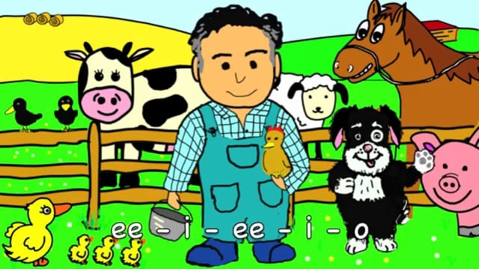

**Let’s learn outside.**

Make a dinosaur world outside, or a safari jungle, or a farm. Cut out pictures and back onto cardboard boxes if you don’t have small world animals.

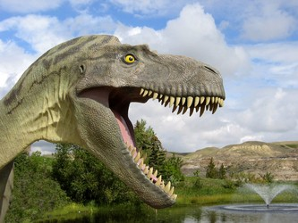 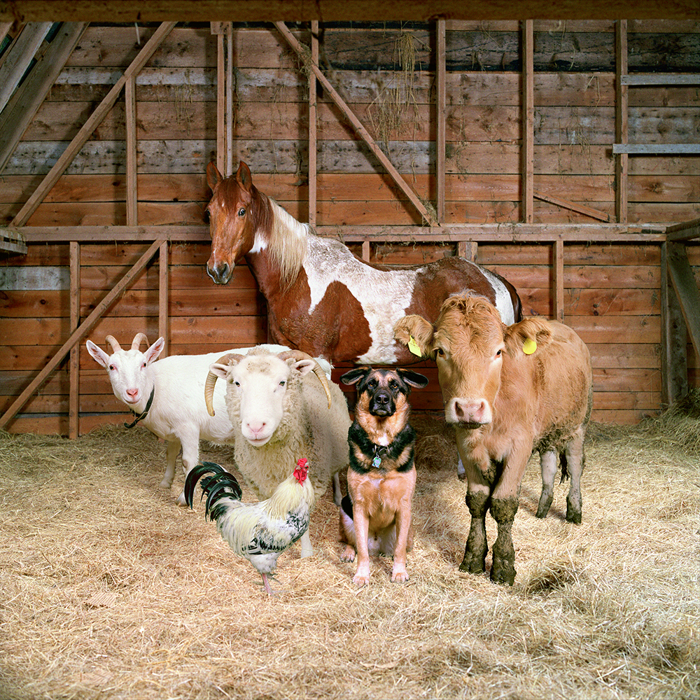 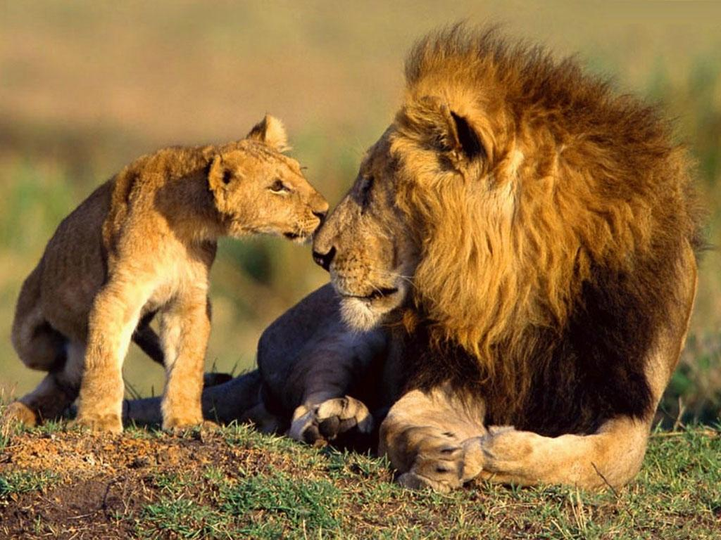

**Developing early maths skills.**

Explore capacity and measurement first hand by emptying and filling different containers. Use dried materials such as dry rice and pasta as well as water to pour.

Use language such as full and empty, more and less.

