**Be creative.**

Make rainbow sensory bottles to engage your children, gain eye contact and spend a few moments calmly observing the colours and movements in the bottle.

* Use a clear plastic water bottle.
* Fill with water and add a few drops of food colouring.
* Add beads, stones, glitter, sequins, dried rice and pasta.
* Make sure the lid is secured.
* You can make a collection of bottles with different colours inside.

**We books.**

Encourage your child to listen to stories, point at pictures and talk about what they can see. Build a quiet 5 minute story time into your daily routine.

Brown Bear Brown Bear by Eric Carle

Planting a Rainbow by Lois Ehlert.

**Let’s learn outside.**

What’s the weather like today?

Look around you and look at the sky. What colour is it today?

Can you feel the rain, the wind or the sun?

   

If it’s raining and sunny search for a rainbow.

Can you find some dandelion seeds and blow them away?

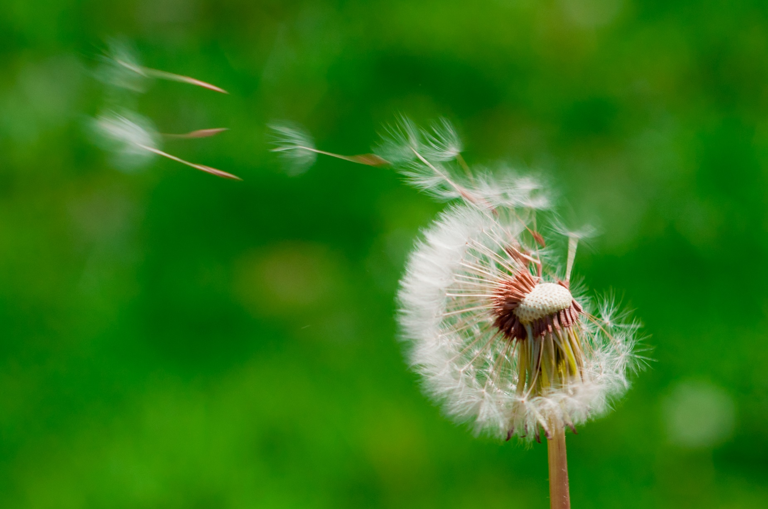

U3s

Colours of the rainbow 