This week is the last week of term. Let’s celebrate the time we all had learning together and having fun by planning a tea party in our own back yards, gardens, or front rooms!
PLAN
Plan what food you want to make and write a shopping list.

Invite you family that are in your bubble and all your favourite teddies and toys.
Don’t forget to tell them the day, the time and the place.
Practice signing your name and lots of kisses x x x x x
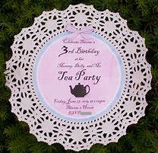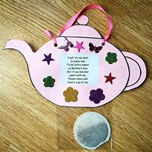

DECORATE
Make some bunting. You can cut out triangles from magazines or newspapers, or cut out strips from a carrier bag. You could also use old fabric to sellotape to a piece of string and wool to make bunting.
A good ‘no stick’ bunting is to draw your own pictures and designs and peg them up.
You can draw on doilies and thread wool or string through.
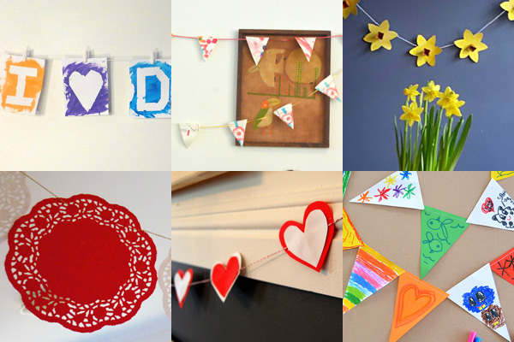
Decorate the table with drawings, flowers in a vase or anything beautiful to make your tea table look nice and interesting. You may want to have a theme, such as the sea side and use shells.

Practise your writing again by making a menu.

Food suggestions
Cucumber and cheese spread sandwiches
Fairy cakes
Jam tarts

Please take a photo of your tea party and send it in to us so we can put them all together as a big goodbye and happy summer wave.

Summer Tea Party

GET EVERYONE INVOLVED
SUMMER PROJECT
This summer the RSPB has a guide to making your own bug hotel as part of give nature a home project.
https://www.rspb.org.uk/get-involved/activities/give-nature-a-home-in-your-garden/garden-activities/build-a-bug-hotel/
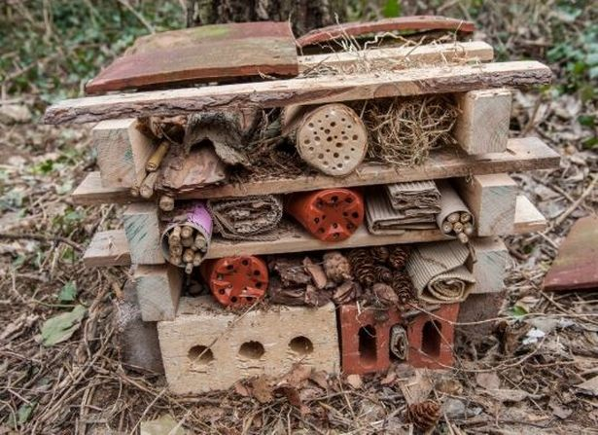
HAVE LOTS OF FUN

RECIPES

JAM TARTS
Ingredients
- 85g/3oz unsalted butter or margarine
- 170g/6oz self-raising flour, plus extra for dusting
- 20 tsp jam, or to taste

Method
- Preheat the oven to 200C/180C Fan/Gas 6.
- Rub together the butter or margarine with the flour in a bowl until it resembles breadcrumbs. Stir in a few tablespoons of water to form a dough. Roll out on a lightly floured surface. Use a pastry cutter to cut out about 20 circular shapes.
- Put each pastry case into an individual cupcake tin. Add a teaspoon of jam to each case – not too much or it will ooze everywhere. If there is any leftover pastry, re-roll it and cut smaller shapes, either circles or stars, and put over the jam to act as the lids.
- Bake for about 30 minutes, or until the pastry has gone pale brown (check the tarts after 20 minutes).

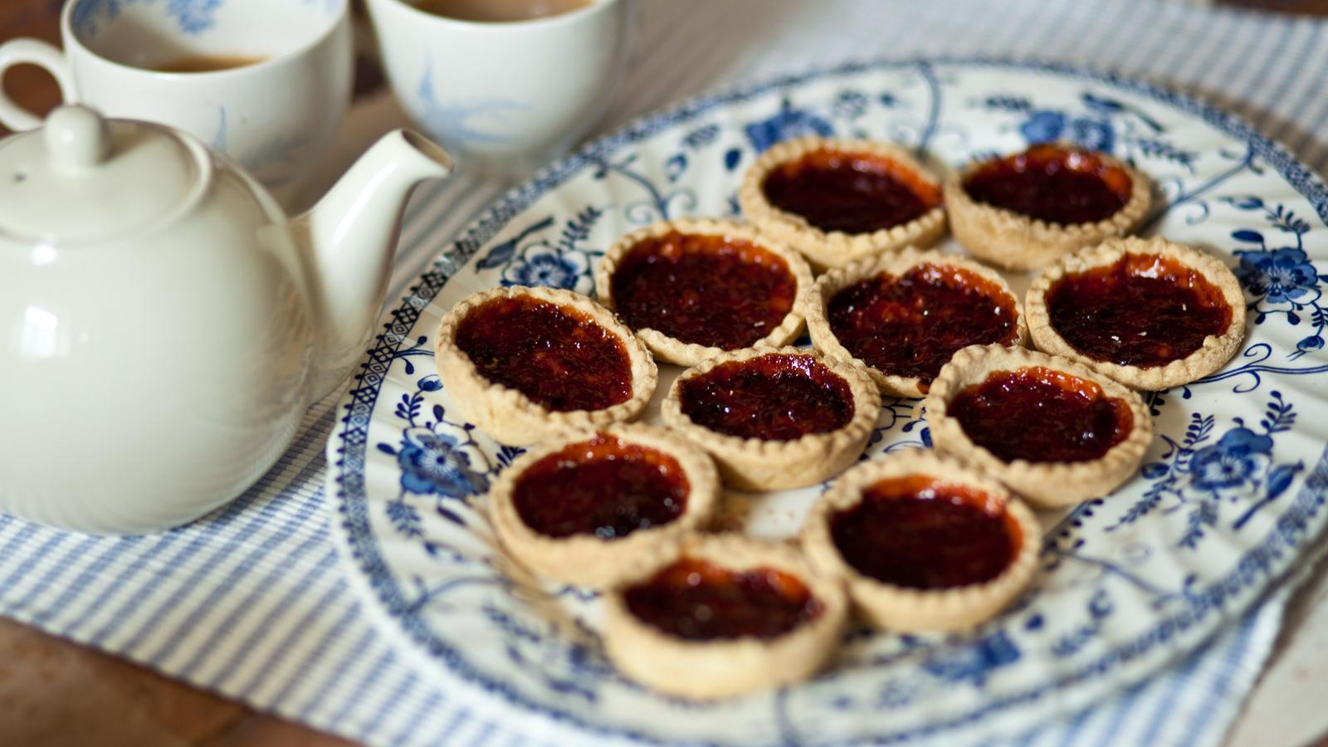

Getting Ready for School
Have fun learning together with your child and helping them to develop the skills they need to become successful learners at school.
LIBRARY BOOKS AND BAGS
We will be collecting in all school book bags and library books this week. Please check at home that all school library books have been returned.
Thank you
Developing early phonic skills. Segmenting and blending
If you are going into reception class in September we all wish you lots of love and hope you enjoy your new school. We have missed you all these last few months and hope that we can arrange a walk by good bye this week, we have a little present for you.
Please phone school on 01942 705301 to arrange a time to come and wave good bye xxxxxx

