**Have fun baking together.**

**JAM TARTS**

**Ingredients**

* 85g/3oz unsalted butter or [margarine](https://www.bbc.co.uk/food/margarine)
* 170g/6oz [self-raising flour](https://www.bbc.co.uk/food/self-raising_flour), plus extra for dusting
* 20 tsp [jam](https://www.bbc.co.uk/food/jam), or to taste

**Method**

* Preheat the oven to 200C/180C Fan/Gas 6.
* Rub together the butter or margarine with the flour in a bowl until it resembles breadcrumbs. Stir in a few tablespoons of water to form a dough. Roll out on a lightly floured surface. Use a pastry cutter to cut out about 20 circular shapes.
* Put each pastry case into an individual cupcake tin. Add a teaspoon of jam to each case – not too much or it will ooze everywhere. If there is any leftover pastry, re-roll it and cut smaller shapes, either circles or stars, and put over the jam to act as the lids.
* Bake for about 30 minutes, or until the pastry has gone pale brown (check the tarts after 20 minutes).

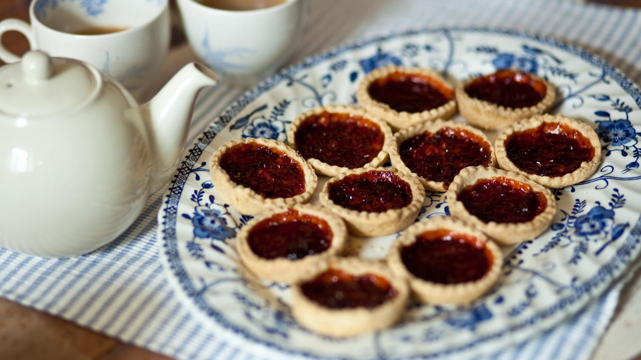

**GET EVERYONE INVOLVED IN A SUMMER PROJECT**

This summer the RSPB has a guide to making your own bug hotel as part of ‘give nature a home project’.

https://www.rspb.org.uk/get-involved/activities/give-nature-a-home-in-your-garden/garden-activities/build-a-bug-hotel/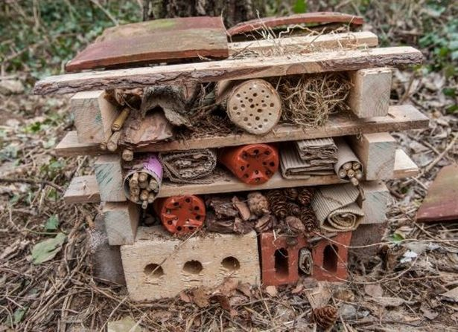

**HAVE LOTS OF FUN**

If the weather is nice and you are outside, take of your shoes and socks and let children feel the grass on their toes. This is a lovely sensory, mindful experience for children.

Over the summer try and spend lots of time in the fresh air, even take your breakfast outside and listen to the morning birds.



Plan a picnic with your child, you could have it in your back garden, back yard or even in your front room.

Let your child make the sandwiches and food with you. Why don’t you invite people from your family bubble to come and join in.

Send us your photos!

**PICNIC TIME U3s** 